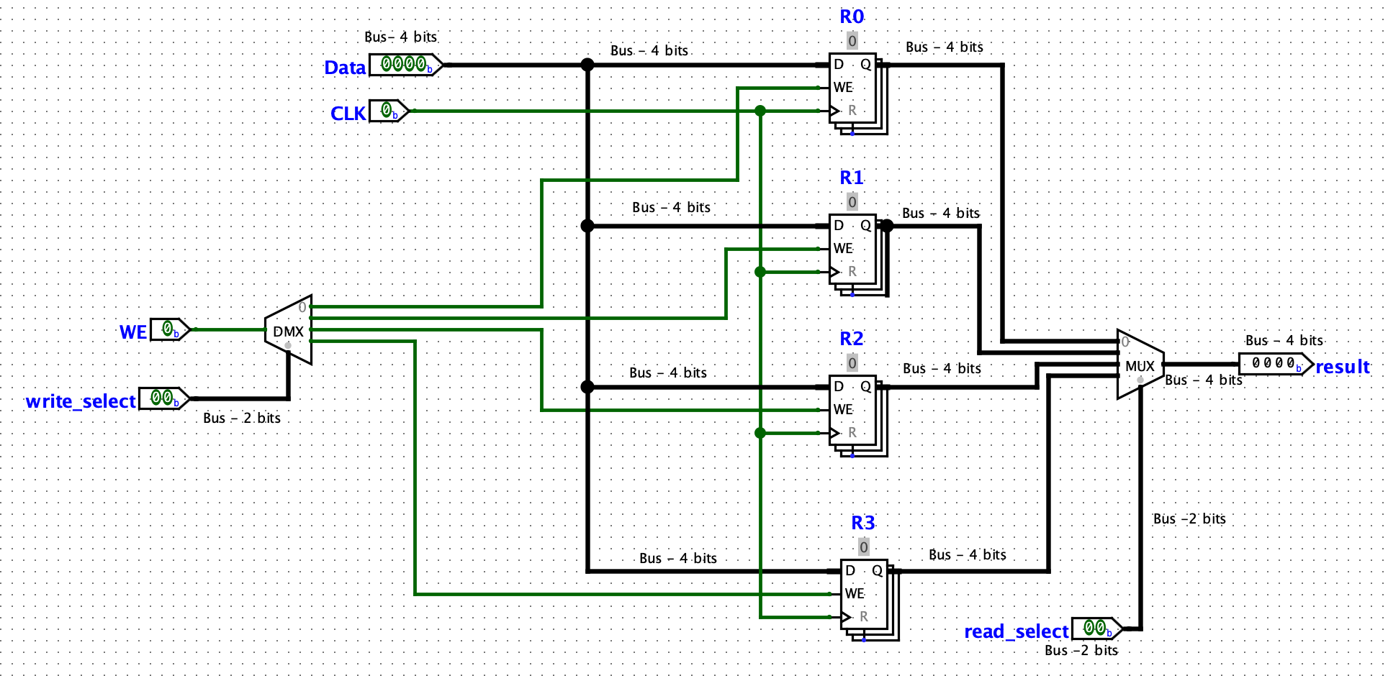**Circuit Diagram:**

**Q1: All four registers will be providing output at the same time. How do you choose one to be the output for the whole register file? What are the bit-widths of inputs of the device that chooses?**

* Using the multiplexer, we are able to input a 2 bit-select (read_select) value that will allow only one of the input values to be selected and then outputted. The bit-widths of the input that the device chooses is 4 bits. This is because the data that is entered into the register file is 4 bits in width; hence, since the data is not being altered, the output would also be 4 bits in width.

**Q2: Only one register should store the input value on the positive edge of the clock. Here are two options, only one of which is correct: you could use a 1-bit demux to send the enable bit to only one register, or you could use a 4-bit demux to send the input to only one register. Which option should we choose and why? Hint: Remember that a demux sends the input value to the selected output line. The other output lines will have the value 0.**

* I chose the 1 bit demux to send an enable bit to one register as it would send an output of 1 to one register with rest being 0. Thus, when the write enable (WE) is high, and the 2 bit select (write_select) chooses which register to send 1 to, the data will be written to that specific register maintaining the states of the other registers. We should choose the 1-bit demux to send the enable bit to only one register over using a 4-bit demux to send the input to only one register because with the latter implementation, every time a data value is written to a register the rest of the registers are overwritten with 0000; their states are altered and that is not the required functionality. Thus, we must use the 1 bit demux to send an enable bit to one register.